The Impact of Central Clearing on the Interest Rate Swaps Market

Arnob L. Alam

# Introduction

The 2006-2008 financial crisis, the most severe downturn since the Great Depression, led to the passage of the Dodd-Frank Wall Street Reform and Consumer Protection Act (DFA). A key provision of the DFA required certain financial contracts to be cleared through a central counterparty (CCP). This study investigates the causal impact of this clearing mandate on prices, volatility and liquidity in the interest rate (IR) swaps market, a major derivatives market used for hedging or speculating on interest rate risk. This is the first examination of the impact of central clearing mandates on this market and contributes to understanding the effects of post-crisis market reforms and informing future regulatory adjustments.

Despite extensive theoretical literature on central clearing, empirical studies are limited. Earlier research focused on the credit default swaps (CDS) market using event studies. Event studies cannot isolate causal impacts due to potential confounding factors. This study addresses the gap in the literature by (1) examining the IR swaps market, which is larger and more widely used than the CDS market and (2) using a difference-in-differences approach to identify causal effects of the clearing mandate. Leveraging the fact that initial central clearing rules targeted IR swaps in the four largest currencies (USD, GBP, EUR, JPY) traded in the US, and did not apply to other currencies or regions, this research plausibly identifies the causal impact of the regulation on pricing, liquidity and price volatility in the IR swaps market.

The paper is organized as follows: section 2 provides background on the IR swaps market, the financial crisis, and the clearing mandate's role in post-crisis market reforms; section 3 develops the theory of pricing, price volatility and liquidity for IR swaps under a clearing mandate; section 4 discusses the identification strategy; section 5 details my data; section 6 discusses the results and section 7 concludes.

# Background

## Interest Rate Swaps

IR swaps are financial derivatives used to hedge or speculate on interest rate movements. The three most common types of IR swaps include vanilla fixed-for-floating swaps, basis swaps, and cross-currency basis swaps. Vanilla fixed-for-floating swaps are the most prevalent. In this type of swap, one party exchanges fixed-rate coupon payments for floating-rate payments on a notional principal. Firms use these instruments to convert floating-rate risk to fixed-rate risk, and vice versa. As a concrete example, imagine firm A can borrow at the London Interbank Offer Rate (LIBOR, a common variable interest rate used by banks when lending money to each other) or a fixed rate of 2.0%, while firm B can borrow at LIBOR + 0.25% or a fixed rate of 1.75%. Suppose firm A prefers borrowing at a fixed-rate and firm B prefers borrowing at a floating-rate (this could be because firm A owns assets such as fixed-income securities while firm B owns assets that pay a variable rate, and the firms would like to match assets with liabilities). Despite their preferences, firm A has a comparative advantage in borrowing at a floating-rate, and firm B in borrowing at a fixed-rate. To achieve their preferred arrangements, the firms can enter into an IR swap agreement with a $1M notional principal, where firm A receives a floating rate of LIBOR from firm B and pays a fixed rate of 1.75% to firm B. This transforms firm A's floating-rate liability into a fixed-rate one and vice versa for firm B. The IR swaps market allows firms to borrow in the market they have a comparative advantage in and trade for their preferred interest rate arrangement.

IR swaps can be bespoke contracts, customizable to individual economic needs. As the largest over-the-counter (OTC) swaps market, it accounted for $465 trillion of the $601 trillion global OTC swaps market in 2010 (von Kleist and Mallo 2011). For many currencies, there are “standardized” contracts, which have common features and are the most heavily traded. During the period of study, the “standard” (most common) US dollar (USD)-denominated IR swaps contract had semiannual payments for one leg and quarterly payments for the other leg (that is either trading quarterly fixed-rate payments for semiannual floating rate payments, or vice-versa), with the 3-month USD-LIBOR curve used both as the floating-rate reference and for discounting future cash flows (see section 3). The day-count convention for the fixed-leg payment is the 30/360 convention and the day-count convention for the floating leg is the Actual/360 day-count convention. For payment schedules, the modified-following business day rule is used. The standard Canadian Dollar (CAD)-denominated contract had CDOR as the reference floating rate. The contract used Actual/365 as the day-count convention for both legs, and used the modified following day-count convention. Both Canadian and US dollar denominated contracts used the ISDA master-agreement, which specifies settlement, termination and other contract specifications. Standard contracts denominated in other currencies (e.g. EUR, GBP, and JPY) have their own conventions as well. The contract specifications can be changed to meet the requirements of the counterparties, but such non-standard contracts are likely to be less liquid than the standard contracts.

The IR swaps market is dealer-dominated, with dealer-customer and dealer-dealer trades accounting for 80% of notional value (Bolandnazar 2020). Bolandnazar finds that 50% of trades (by notional value) are executed by the largest seven dealers, indicating market concentration among a few dealers. This concentration can impact pricing and market stability in several ways. Larger dealers might be able to reduce search costs by easily finding a counterparty from the dealers’ large client base. They could also reduce transactions costs by economizing over administrative and warehousing costs of contracts. However, because of their market position, they might have market power and be able to charge a premium over what would prevail in competitive markets. The failure of a large dealer (or a dealer’s major counterparty) could also drastically reduce liquidity in the system and increase transactions costs (this is expanded upon in the simulation section below).

## Central Clearing

When a swap is cleared, the initial contract between the two parties is replaced by two contracts between each party and a central clearinghouse/derivative clearing organization (CCP, DCO or clearinghouse). The clearinghouse becomes the counterparty for each leg (that is, paying the fixed leg to the initial party receiving fixed-leg payments and paying the floating leg to the party receiving the floating leg-payments. It also receives the floating leg from the initial party paying the floating rate and the fixed leg from the initial party paying the fixed leg). If one party fails to meet their contractual obligation, the clearinghouse can still make sure the other party gets paid. Clearinghouses have access to additional funds to make a counterparty whole in case of default by the other. When counterparties clear their trade through a clearinghouse, they must put up collateral (initial margin) and contribute to a default fund. In case the risk position of the counterparty changes, it can be required to put up additional collateral (variation margin). The CCP also has equity (CCP capital), default fund contributions of other members and access to other lines of credit such as the Federal Reserve discount window. The combination of these resources (collateral, default fund, CCP capital and other sources of credit) make it unlikely that the failure of one counterparty would drastically affect the whole market. Since clearing members can lose their contribution to the default fund in case of the failure of a counterparty, clearing mutualizes counterparty risk among the members of the clearinghouse.

In addition to these financial resources, clearinghouses are generally large financial institutions that are supposed to exercise prudent risk control measures such as monitoring members’ trading positions and liquidating distressed assets in an orderly fashion. Since the clearinghouse can observe all the trades that it is clearing, it has a better picture of overall riskiness of each member. In a bilateral market, the counterparty is unaware of what other trades its partner is entering, and so does not have a thorough understanding of its riskiness.

Clearing can also reduce demand for collateral through a practice called netting. There are two types of netting practices common in the industry: cross-product netting and multiproduct netting. For a clearinghouse that clears multiple types of contracts (e.g. interest rate swaps, forward rate agreements, overnight-index swaps, credit default swaps, etc.) cross-product netting involves netting across different derivatives products. For example, if firm A owes the CCP $10 million in collateral for IR swaps, but the CCP owes firm A $8 million for CD swaps, then firm A can just pay the CCP $2 million in net collateral. Multilateral netting involves netting payments across multiple firms. For example, consider the following series of obligations: firm A owes firm B $100 million and firm C $200 million; firm B owes firm A $50 million and firm C $150 million; firm C owes firm A $100 million and firm B $100 million. Without multilateral netting, the firms can still engage in bilateral netting. The following payments would need to be made: firm A would need to pay firm B ($100 - $50) = $50 million and firm C ($200 - $100) = $100 million; firm B would need to pay firm C ($150 - $100) = $50 million. The total collateral demand would be $200 million. With multilateral netting by the CCP, the $50 million “transitive” payment from firm A to B to C can be eliminated. Firm A would pay the CCP $150 million and the CCP would pay firm C $150 million (while firm B would not make any payments at all). The total collateral demand would be $150 million.

Figure 1 (a) Example of obligations between three firms and (b) payments under bilateral netting and (c) payments under multilateral netting

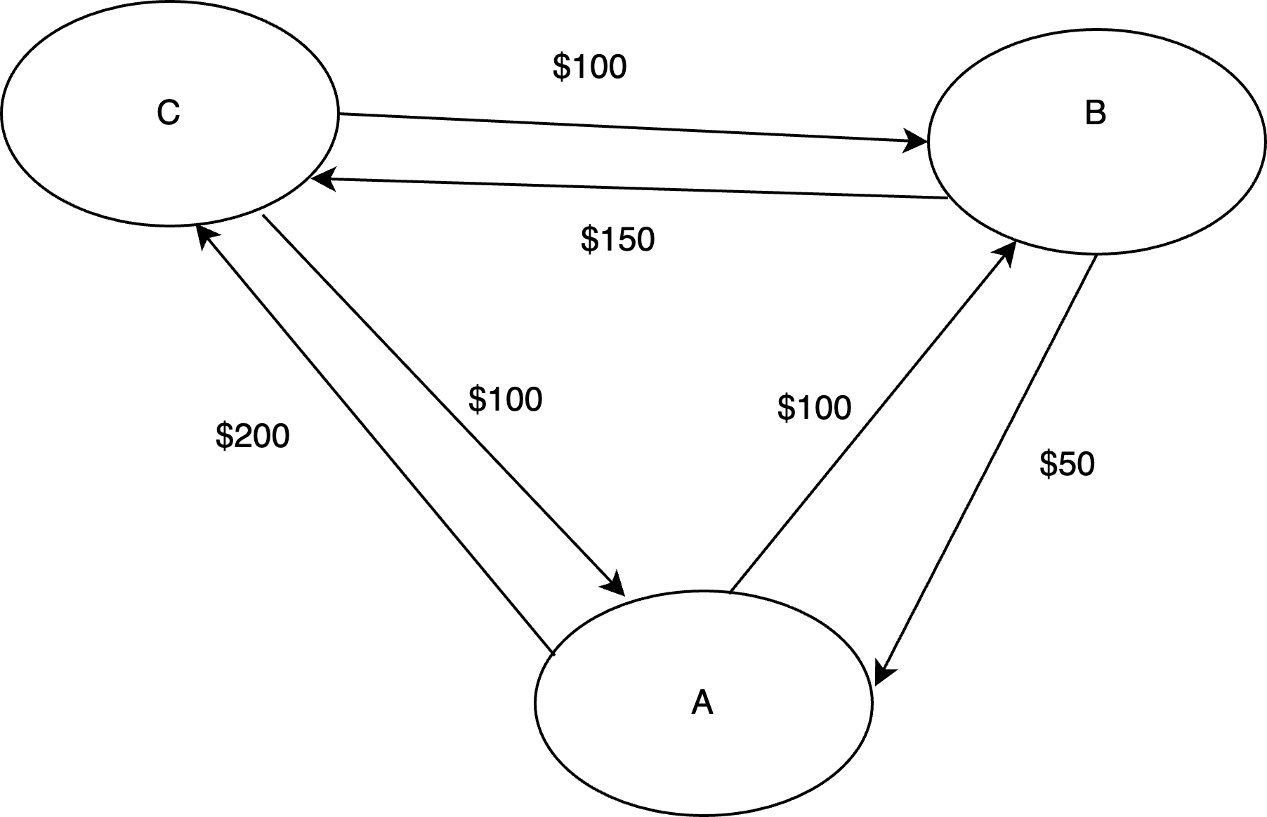(a)

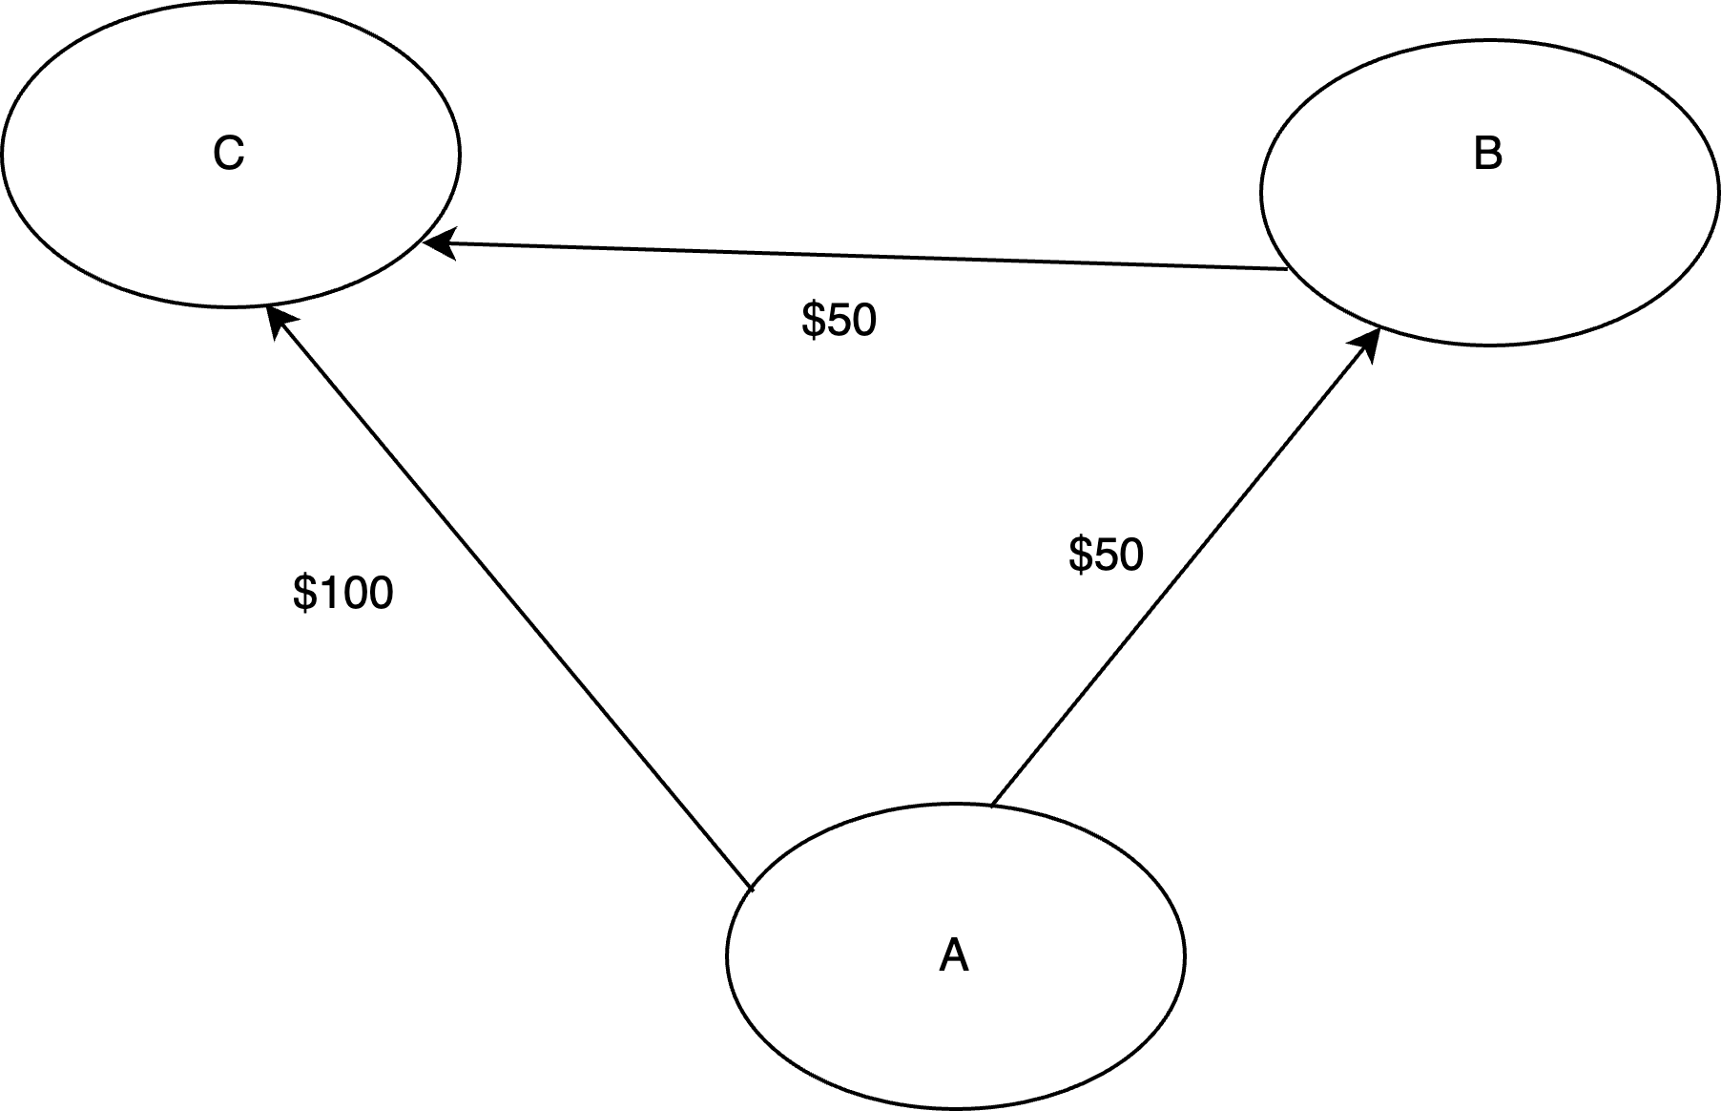(b)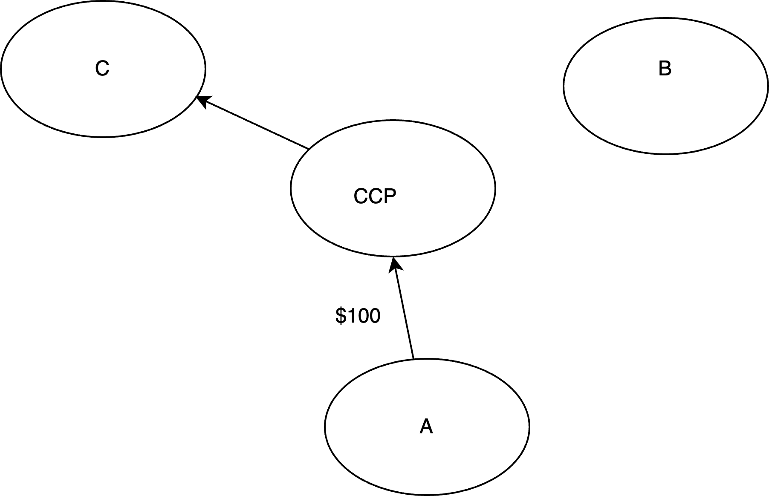(c)

Originally created for members of futures and equities exchanges, clearinghouses became more significant with regulations like the DFA (2010) and European Market Infrastructure Regulation (EMIR, 2012) mandating central clearing of derivatives. Mandated clearing can have macro and micro effects on the swaps market. At the macro level, clearing could reduce volatility but also strain the market through collateral demand during volatile or illiquid periods. Large enough losses could threaten clearinghouse solvency, transmitting effects to all members. At the micro level, central clearing may change the types of trades firms enter, potentially leading to riskier trades due to mutualized default risk (adverse selection) and riskier post-trade activities (moral hazard). Clearing is subject to economies of scale and scope, which could lead to natural monopolies. However, regulators are likely to prevent this through local clearinghouse requirements (that is, even though a single clearinghouse for US and Europe might have lower costs, regulators might require the clearinghouse to be geographically located in their jurisdiction, requiring two clearinghouses) and antitrust scrutiny. While clearinghouses can reduce default risk and collateral demand, they also require resources for risk management activities, which may increase trading costs.

## Regulatory Background

### US Context

Following the financial crisis, Congress passed the DFA to enhance the US financial system's reliability. Since over the counter (OTC) derivatives markets played a role in the crisis, DFA aimed to significantly reform this market. Key objectives included improving trade data availability for regulators and market participants, requiring real-time reporting of certain trade characteristics, and mandating confidential trade data reporting to swaps data repositories and regulators.

To reduce default risk for large swaps dealers, DFA requires dealers to register with the Commodities Futures Trading Commission (CFTC) or the Securities and Exchange Commission (SEC), adhere to internal business conduct standards and maintain adequate capital. To enhance liquidity, price discovery and transparency, it encourages trading to take place in centralized Swaps Execution Facilities (SEFs) or Designated Contract Markets (DCMs). To make trade data more readily available, it requires real-time reporting of price information to swaps data repositories (SDRs) and submitting additional data (called primary economic terms) to SDRs or the CFTC/SEC in a timely fashion. Furthermore, the DFA mandates most contracts be centrally cleared (and for uncleared contracts, requires parties to post margin to mitigate default effects). Table 1 summarizes the CFTC key rulemaking in these areas.

Table 2 Major Dodd-Frank Act Rulemaking Areas

|  |  |
| --- | --- |
| Rulemaking Area | Major Rules |
| Swaps Dealers and Major Swaps Participants | * Registration * Internal Business Conduct Standards * Capital and Margin for non-banks * Segregation and Bankruptcy |
| Data Requirements | * Establishment of Swap Data Repositories (SDR) * Data recordkeeping and reporting requirements * Real Time Reporting * Large Swaps Trader Reporting |
| Clearing Requirements | * Establishment of Derivatives Clearing Organizations (DCO/CCP) * Clearing requirement for most common swaps * Margining requirements for uncleared swaps |
| Trading Requirements | * Establishment of Swaps Execution Facilities (SEF) * Made Available for Trade (MAT) designation/requirement |
| Position Limits | * Position Limits and Aggregation of Positions |
| Enforcement | * Anti-Manipulation * Disruptive Trading Practices * Whistleblowers |
| Other | * Investment Adviser Reporting * Volcker Rule * Reliance on Credit Ratings * Fair Credit Reporting Act * Cross-Border Applications |

### International Context

Considering the global nature of the financial system, regulators collaborated internationally to harmonize regulatory requirements. In Europe, the EU passed EMIR in 2012, which shares similar aims with DFA, while the Bank of England (BoE) issued regulations mandating clearing for most trades involving UK-based entities. In Asia, the Japanese Financial Services Authority (JFSA) required yen-denominated IR swaps and certain CD swaps to be cleared by the end of 2012; the Monetary Authority of Singapore (MAS) and the Securities and Futures Commission (SFC) of Hong Kong released consultation papers expressing their intentions to clear swaps denominated in certain Asian currencies. Table 2 summarizes the international context:

Table 3 Summary of Central Clearing Requirements in Major FInancial Centers

|  |  |
| --- | --- |
| Jurisdiction | Relevant Laws and Regulations |
| North America | * DFA (2010) and CFTC and SEC rulemaking requires mandatory clearing of IR swaps contracts denominated in USD, GBP, EUR and JPY LIBOR by September 2013. * Additional currencies and classes of contracts are added to the clearing requirement in 2016 to harmonize regulations across jurisdictions. * Canada requires certain CAD-denominated swaps to be cleared starting in May 2017. |
| Europe | * EMIR passes in 2012 and requires clearing of certain IR swaps contracts. Regulations come into effect in March 2013. * Bank of England releases financial market regulatory guidance in April 2013, reiterating the applicability of EMIR to UK-based traders. * Additional currencies and classes of swaps are added to the EU clearing requirements in 2016. * Switzerland established a clearing mandate for Switzerland based swaps in 2017. |
| Asia | * Japan Financial Stability Authority (JFSA) requires yen denominated IR swaps referencing LIBOR to be cleared by end of 2012. * Hong Kong Monetary Authority (HKMA) and the Securities and Futures Commission (SFC) release consultation paper in 2011 on clearing of certain IR swaps denominated in Asian currencies. * Hong Kong requires HKD denominated swaps to be cleared starting July 2017. * Monetary Authority of Singapore (MAS) releases consultation paper in 2011 on plans for clearing of certain Singapore Dollar denominated IR swaps. * MAS requires SGD contracts to be cleared by December 2017. |
| Australia | * Australian Council of Financial Regulators (CFR) pass legislation requiring mandatory clearing of Australian dollar denominated IR swaps by end of 2012. |

# Theory

## Pricing of Interest Rate Swaps

### Without credit risks

An interest rate swap can be thought of as an exchange of a series of fixed payments by one party for a series of variable (floating) payments by the other party involved in the swap. For the fixed leg, the present value of the payments is given by:

Where: CF is the (fixed) cash flow, is the risk-free rate for period , is the time at which CF will be received and is the tenor (total length of the swap contract)

The present value of the floating leg is:

Where: is the floating leg payment at period , and all the other variables are as defined previously.

The present value of the contract for the party paying the fixed leg and receiving the floating leg is:

*(The counterparty's value is given by a similar formula, but with the signs reversed on the right-hand side.)*

Floating rate payments are unknown in advance but are usually forecasted by a relevant yield curve. For instance, if the floating leg payment is based on USD LIBOR, the USD LIBOR curve, constructed by interpolating short-term deposit rates, medium-term Eurodollar futures, and long-term instruments like forward rate agreements and existing swaps, is used. At the outset of the contract, its value is zero. This is achieved by determining the present value of the floating leg using the forecasted payments (using the LIBOR yield curve), and then setting the fixed rate payment such that the present values of both legs equal.

### Counterparty Risk and Credit Valuation Adjustment/Debit Valuation Adjustment

The interest rate swap market is dominated by a handful of substantial swap dealers (SDs) and Major Swap Participants (MSPs) rather than many atomistic market participants. These SDs and MSPs offer buy and sell quotes for swaps, potentially finding other participants to balance their swap exposures. Figure 1 depicts a hypothetical network model of such a market.Diagram

In the figure, three dealers (D) each engage with their set of clients (C). Note that dealers might engage in interdealer trading (indicated by bi-directional arrows between dealers) and bulk futures markets trading (not shown) for cash flow or risk management purposes. Customers can trade with multiple dealers (indicated by arrows going from C to multiple Ds) or occasionally engage in bilateral trades (indicated by arrows going from C to C) amongst themselves. However, bilateral trades typically have low volume. It is believed that the dealer-centric network structure lowers search costs compared to a direct customer-to-customer market.

In practice, customers and dealers must account for the risk associated with counterparties defaulting. The "risk-free" present value pricing above needs to be adjusted for this risk. If *Si*​ represents the survival probability of the counterparty at period , the expected present value of the fixed leg is:

The fixed rate payment needs to account for the modified PV of the floating leg.

(Note that a swap's valuation with counterparty risk requires two adjustments. Only the credit valuation adjustment [CVA] is shown above. However, if one’s counterparty defaults, one no longer has to make his/her obligated payments to the other party either, which would increase the value of the contract, called the Debit Value Adjustment [DBA]).

### Central Clearing

The structure of a dealer-dominated market means that a dealer's failure (possibly due to inadequate risk management or correlated customer defaults) could affect other dealers and potentially the entire market. To counter this, regulators introduced central counterparties (clearinghouses). These clearinghouses void (novate) the initial swap contract and establish two new contracts, mirroring the original, with each counterparty. Now participants only need to be concerned about the clearinghouse's potential default, rather than their counterparties. Owing to their robust capitalization, regulation, and sound risk management, clearinghouses are perceived to decrease default and contagion risks. Figure 2 visualizes a hypothetical market structure with mandated central clearing.

If clearinghouses can reduce or eliminate counterparty risk, swaps values should be closer to the risk-free case rather than the case with counterparty risk. However, even if clearinghouses are successful at eliminating counterparty risk, additional cost of compliance (such as clearing fees and margin requirements) could keep swaps prices from reaching the risk-free valuation.

## Model of Liquidity (Bid-Ask Spreads)

### With No Counterparty Risk

I adapt the model from Biais (1993) for centralized trading where all market participants can observe the bids, asks and market orders of their market participants. The model is a sequential game. In the first stage, two competing dealers (liquidity providers) receive a random inventory position in the risky asset between [-R, R]. In stage 2, the dealers set their bid and ask prices. In the next stage there is a liquidity shock with probability . If there is a liquidity shock, a liquidity trader (liquidity demander) receives an inventory of quantity with probability (or a short position of size with the same probability). He then decides the size of the optimal market order, which is executed at the best bid or ask price posted by the dealers. If there is no liquidity shock, no trade takes place. In the final stage, the price of the risky asset is realized, and players receive their utility.

I assume that the two dealers are identical except for their inventory positions. All market participants have constant absolute risk aversion (CARA) utility , where is the trader’s wealth and is a risk-aversion parameter. If there is a liquidity shock, the liquidity trader observes the market prices and selects the quantity (size) of the market order. The final price of the risky asset is , where .

I analyze the case where the liquidity trader receives a liquidity shock (the case where the liquidity trader receives a shock will be analogous). At the end of the game, once the asset price is realized, this trader receives wealth:

where is the net position of the trader in the risky asset at the end of the game and is the cash from selling units of the risky asset at the best (highest) bid price. The liquidity trader will maximize his expected utility . The optimal quantity is:

where I have used the fact that

In the case of the reservation quote for dealer 1, competing over a market buy order. If he has the best price, he receives the order flow and has wealth:

where: is the bid price set by dealer 1, is the size of the market order and is his random inventory position (a number between ). If he does not have the best price, he receives:

Dealer 1 is indifferent between trading and not trading when the expected utility from both actions is the same. This happens when:

where the price is subscripted with to emphasize it is the reservation price. A similar analysis holds for the ask price:

and in general, for dealer , the reservation prices are:

I analyze the case of the optimal bid quote for dealer 1, assuming competing dealers do not observe the other’s inventory levels, but both assume that the others inventory is drawn uniformly from . By increasing his bid quote, a dealer increases his probability of winning the order flow, but he must balance this against the fact that he pays more for each unit acquired. He would not like to increase his quote beyond his reservation price. The optimal bid quote is:

Similarly, the optimal ask quote is:

and in general, the optimal bid and ask quotes for dealer are:

The observed bid ask spread is:

NB: Under competition with many dealers, the second term on the RHS of the above equation is , which approaches as , and the bid ask quotes become the reservation quotes.

### With counterparty risk

Under the scenario where there is counterparty risk, if the counterparty defaults the value of the asset is impaired (the holder of the non-defaulting leg no longer receives expected cash flows). However, for the defaulter, the value of the asset is enhanced (as he no longer needs to make payments). I model this as an additional shock to the realized value of the asset: . The analysis remains essentially the same, but the optimal market order size, reservation prices, and optimal quotes now become:

## Models of Price Volatility

### Markets without Counterparty Risk

I develop an original model of price volatility. There are two sets of agents: market-makers who post bid and ask prices, and liquidity traders who post market orders. Assume that order-flow (net market-buy or market-sell orders) in one period are i.i.d Normal with variance :

Market-makers adjust their next period price based on the current period’s observed order-flow:

Where: is a parameter for the market-makers’ sensitivity to order-flow.

The expression for the volatility in this case is:

### Price Volatility in Markets with Counterparty Risk

I modify the above model to include additional order-flow dynamics related to counterparty risk. Assume that when the current period’s order-flow is negative, there is additional sell-off of the risky asset in the next period due to (perceived) additional counterparty risk, and when the current period’s order flow is positive, there is additional buying of the risky asset in the next period due to (perceived) reduction in counterparty risk. The order-flow dynamics are now given by:

Where:

The expression for the price change becomes:

Where I have used the fact on the 3rd line and that .

# Identification Strategy

## Pricing

I investigate the causal impact of the central clearing mandate on the interest rate swap prices by comparing the premium above the fair rate (that is, the difference between the “riskless fixed rate” described in 3.1.1 and the observed fixed rate on an actual contract) on USD denominated swaps versus the premium on CAD denominated swaps before and after the mandate. I employ a difference-in-differences (DiD) identification strategy, with the CAD denominated swaps acting as the control group, which allows me to plausibly isolate the causal effect of the mandate on the swap premiums by exploiting the variation in the timing of the policy implementation.

I begin by selecting a sample of interest rate swaps denominated in both USD and CAD from the ten trading days before and after the central clearing mandate was implemented. I create two groups based on the currency of denomination: (1) the treatment group, consisting of USD denominated swaps that were affected by the central clearing mandate, and (2) the control group, consisting of CAD denominated swaps that were not subject to the mandate during the same period. By comparing the swap premiums between these two groups before and after the mandate, I can plausibly identify the causal effect of the policy on swap premiums if both groups would have followed parallel trends in the absence of the clearing mandate.

To estimate the causal effect of the central clearing mandate on swap premiums, I employ a DiD regression model, which takes the following form:

Where is the swap premium for swap at time , is an indicator variable equal to 1 if the swap is denominated in USD (treatment group) and 0 otherwise (control group), is an indicator variable equal to 1 for the period after the mandate was implemented, and is a vector of control variables. The coefficient of interest is δ, which captures the causal effect of the central clearing mandate on swap premiums.

To ensure the validity of the identification strategy, I first test the parallel trends assumption by visually inspecting the pre-treatment trends of swap premiums for both treatment and control groups and conducting placebo tests. Additionally, I perform several robustness checks, such as using alternative control groups, and placebo DiD.

## Liquidity

Identification strategy goes here.

## Volatility

Identification strategy for price volatility goes here.

# Data

The Commodity Futures Trading Commission's (CFTC) clearing mandate on IR swaps became effective on March 11, 2013. The regulation was implemented in three phases. Phase 1 mandated clearing for certain IR swaps involving swap dealers (SD), major swap participants (MSP), or active funds. Phase 2 extended the mandate to additional entities, including commodity pool operators, banks and other financial institutions, while Phase 3 covered all remaining entities (unless exempted). The CFTC defined contract specifications for swaps that must be cleared. These specifications included the currency (USD, GBP, EUR, JPY), the contract tenor (28 days to 50 years for USD, GBP and EUR based contracts, 28 days to 30 years for JPY bases contracts), and the floating leg reference (LIBOR or EURIBOR). It also specified “negative” characteristics (that is, swaps having these characteristics do not need to be cleared) including no dual currencies, no conditional notional amount and no optionality. The IR swaps covered by the mandate were the largest categories by volume.

I compare prices, price volatility, and liquidity before in each of the three phases, comparing USD and CAD denominated swaps – the largest regulated and unregulated markets, respectively. To minimize the impact of interest rate policy and other macroeconomic variables, I analyze a small ten-day trading window before (Feb 25 – Mar 8, May 27 – Jun 7 and Aug 26 – Sep 6) and after (Mar 11 – Mar 22, Jun 10 – Jun 21 and Sep 9 – Sep 20) the regulation's effective date in each phase. The data are reported by the Depository Trust and Clearing Corporation Swaps Data Repository (DTCC SDR) and obtained using the SDR screen of the Bloomberg terminal.

To calculate the theoretical counterparty-riskless price of IR swaps, I forecast future floating rate payments and discount the payments using the appropriate yield curve. I use a single curve method, the prevalent pricing method during the study period. For USD swaps, I obtain the USD semiannual fixed-floating rate curve (curve __) for each trading day from Bloomberg. For CAD denominated swaps, I obtain the Canadian yield curve from the Bloomberg Terminal.

I use the QuantLib-python library to construct the forward curve. For the USD swaps curve, the short-end (3M or less) of the curve is anchored by LIBOR rates; the medium-end (6M – 18M) of the curve is anchored by Eurodollar futures; and the long-end (24M onward) of the curve is anchored by US swap rates. Values between the anchor points need to be interpolated. I use piecewise linear interpolation.

The data elements reported in the DTCC SDR include swap currency, trade date and time, effective date, maturity date, fixed rate, payment frequencies, clearing status, notional value, and capped notional indicator. For USD swaps, USD LIBOR is the floating rate index for 98% of swaps, while for CAD swaps, CDOR is the index for 99% of swaps. I exclude certain swaps such as those that make a single payment at maturity (i.e., payment frequency is 1T). Table 3 shows the notional value and number of trades captured in my data.

There are several limitations to the DTCC SDR dataset. Firstly, the dataset does not identify the counterparties. The identity of the counterparty (and more importantly, its creditworthiness) could have a significant impact on the swap price. In addition, the dataset does not mark which counterparty is the dealer (that is, whether the dealer is receiving the fixed rate or paying the fair rate). When receiving the fixed rate (and paying the floating leg), the dealer is likely to require a premium over the fair price. When paying the fixed rate, the dealer is likely to pay a discount below the fair price. I am also unable to observe non-standard contract characteristics such as early termination previsions, collateral arrangements and day-count and settlement conventions. The standard-version of the interest rate swaps contract uses the International Swaps and Derivatives Association (ISDA) Master Agreement for specifying these contract terms. Deviations from the ISDA master agreement could affect the liquidity of the

Table 4 Number of trades and notional value of USD and CAD denominated IR swaps

(Pre-Phase 1)

|  |  |  |  |  |  |  |
| --- | --- | --- | --- | --- | --- | --- |
| **Currency** | **Floating Leg** | **Cleared (Count)** | **Cleared (Notional Value)** | **Uncleared (Count)** | **Uncleared (Notional Value)** | **Percent Cleared** |
| **USD** | **LIBOR** | 3,518 | 203,345.90 | 3,071 | 131,242.01 | 61% |
|  | USD-Federal Funds-H.15 | 0 | 0.0 | 16 | 2,183.00 | 0% |
|  | USD-PRIME-H.15 | 0 | 0.0 | 2 | 6.00 | 0% |
|  | USD-PRIME-H15 | 0 | 0.0 | 2 | 4.00 | 0% |
|  | USD SPRDL MANUAL | 0 | 0.0 | 1 | 100.00 | 0% |
|  | USD-AAA_MUNI- | 0 | 0.0 | 4 | 31.00 | 0% |
|  | USD-OIS-3 | 0 | 0.0 | 1 | 6.00 | 0% |
|  | IBR | 0 | 0.0 | 2 | 200.00 | 0% |
|  | CLICP | 0 | 0.0 | 1 | 100.00 | 0% |
|  | TIS | 0 | 0.0 | 1 | 1.00 | 0% |
|  | USD-USPSA-BLOOMBERG | 0 | 0.0 | 1 | 4.00 | 0% |
| **CAD** | **CAD-BA-CDOR** | 225 | 18,811.40 | 308 | 20,363.10 | 48% |
|  | CAD-REPO-CORRA | 0 | 0.00 | 3 | 410.00 | 0% |

(Post Phase 1)

|  |  |  |  |  |  |  |
| --- | --- | --- | --- | --- | --- | --- |
| **Currency** | **Floating Leg** | **Cleared (Count)** | **Cleared (Notional Value)** | **Uncleared (Count)** | **Uncleared (Notional Value)** | **Percent Cleared** |
| **USD** | **LIBOR** | 4,342 | 262,257.70 | 2,125 | 76,649.65 | 77% |
|  | USD-Federal Funds-H.15 | 0 | 0.00 | 24 | 3,353.00 | 0% |
|  | IBR | 0 | 0.00 | 6 | 1,050.00 | 0% |
|  | USD-SIFMA Municipal Swap Index | 0 | 0.00 | 6 | 60.00 | 0% |
|  | USD-PRIME-H.15 | 0 | 0.00 | 2 | 6.00 | 0% |
|  | USD-PRIME-H15 | 0 | 0.00 | 2 | 3.00 | 0% |
|  | USD-Prime-H.15 | 0 | 0.00 | 1 | 2.00 | 0% |
|  | USD-USPSA-BLOOMBERG | 0 | 0.00 | 2 | 20.00 | 0% |
|  | CLICP | 0 | 0.00 | 3 | 450.00 | 0% |
|  | USD-AAA_MUNI- | 0 | 0.00 | 2 | 25.00 | 0% |
|  | USD-BMA Municipal Swap Index | 0 | 0.00 | 2 | 6.52 | 0% |
| **CAD** | **CAD-BA-CDOR** | 126 | 9,578.00 | 140 | 11,137.31 | 46% |
|  | CAD-REPO-CORRA | 0 | 0.00 | 3 | 780.00 | 0% |
|  | CDOR | 0 | 0.00 | 5 | 105.60 | 0% |

(Pre-Phase 2)

|  |  |  |  |  |  |  |
| --- | --- | --- | --- | --- | --- | --- |
| **Currency** | **Floating Leg** | **Cleared (Count)** | **Cleared (Notional Value)** | **Uncleared (Count)** | **Uncleared (Notional Value)** | **Percent Cleared** |
| **USD** | **LIBOR** | 6,870 | 426,753.26 | 2,954 | 118,388.28 | 78% |
|  | USD-Federal Funds-H.15 | 0 | 0.00 | 29 | 4,463.00 | 0% |
|  | COOVIBR | 0 | 0.00 | 9 | 1,800.00 | 0% |
|  | CLP-TNA | 0 | 0.00 | 6 | 1,200.00 | 0% |
|  | USD FORM 3750 | 0 | 0.00 | 1 | 100.00 | 0% |
|  | USD-AAA_MUNI- | 0 | 0.00 | 2 | 13.00 | 0% |
|  | USD-BMA Municipal Swap Index | 0 | 0.00 | 1 | 7.00 | 0% |
|  | USD-PRIME-H.15 | 0 | 0.00 | 12 | 62.90 | 0% |
| **CAD** | **CAD-BA-CDOR** | 180 | 14,726.00 | 169 | 14,290.70 | 51% |

(Post Phase 2)

|  |  |  |  |  |  |  |
| --- | --- | --- | --- | --- | --- | --- |
| **Currency** | **Floating Leg** | **Cleared (Count)** | **Cleared (Notional Value)** | **Uncleared (Count)** | **Uncleared (Notional Value)** | **Percent Cleared** |
| USD | **LIBOR** | 7,975.00 | 461,124.51 | 1,449.00 | 53,548.33 | 90% |
|  | USD-Federal Funds-H.15 | 0.00 | 0.00 | 33.00 | 5,068.00 | 0% |
|  | USD-PRIME-H.15 | 0.00 | 0.00 | 5.00 | 26.00 | 0% |
|  | USD-PRIME-H15 | 0.00 | 0.00 | 1.00 | 9.00 | 0% |
|  | USD-Prime-H.15 | 0.00 | 0.00 | 1.00 | 2.00 | 0% |
|  | COOVIBR | 0.00 | 0.00 | 21.00 | 3,750.00 | 0% |
|  | CLP-TNA | 0.00 | 0.00 | 7.00 | 700.00 | 0% |
|  | USD BMA MANUAL | 0.00 | 0.00 | 1.00 | 45.00 | 0% |
|  | USD-AAA_MUNI- | 0.00 | 0.00 | 3.00 | 20.00 | 0% |
|  | USD-BMA Municipal Swap Index | 0.00 | 0.00 | 2.00 | 10.00 | 0% |
| CAD | **CAD-BA-CDOR** | 176.00 | 11,322.08 | 174.00 | 7,969.50 | 59% |

(Pre-Phase 3)

|  |  |  |  |  |  |  |
| --- | --- | --- | --- | --- | --- | --- |
| **Currency** | **Floating Leg** | **Cleared (Count)** | **Cleared (Notional value)** | **Uncleared (Count)** | **Uncleared (Notional Value)** | **Percent Cleared** |
| **USD** | **LIBOR** | 6,112.00 | 396,744.28 | 1,398.00 | 47,355.82 | 89% |
|  | USD-Federal Funds-H.15 | 0.00 | 0.00 | 36.00 | 4,539.00 | 0% |
|  | USD-PRIME-WEIGHTED-AVERAGE | 0.00 | 0.00 | 2.00 | 200.00 | 0% |
|  | USD-PRIME-H.15 | 0.00 | 0.00 | 5.00 | 7.00 | 0% |
|  | USD-PRIME-H15 | 0.00 | 0.00 | 8.00 | 35.56 | 0% |
|  | USD-AAA_MUNI- | 0.00 | 0.00 | 1.00 | 10.00 | 0% |
|  | USD-SIFMA Municipal Swap Index | 0.00 | 0.00 | 1.00 | 5.00 | 0% |
| **CAD** | **CAD-BA-CDOR** | 128.00 | 9,697.20 | 134.00 | 7,487.11 | 56% |
|  | CAD-REPO-CORRA | 0.00 | 0.00 | 1.00 | 35.00 | 0% |

(Post Phase 3)

|  |  |  |  |  |  |  |
| --- | --- | --- | --- | --- | --- | --- |
| **Currency** | **Floating Leg** | **Cleared (Count)** | **Cleared (Notional Value)** | **Uncleared (Count)** | **Uncleared (Notional Value)** | **Percent Cleared** |
| **USD** | **LIBOR** | 7,481 | 485,507.61 | 1,461 | 58,912.20 | 89% |
|  | USD-Federal Funds-H.15 | 0 | 0.00 | 19 | 3,606.00 | 0% |
|  | TREASURY_DTCC_GCF_REPO_INDEX | 0 | 0.00 | 4 | 850.00 | 0% |
|  | USD FORM 3750 | 0 | 0.00 | 1 | 30.00 | 0% |
|  | USD-AAA_MUNI- | 0 | 0.00 | 9 | 56.00 | 0% |
|  | USD-BMA Municipal Swap Index | 0 | 0.00 | 3 | 13.00 | 0% |
|  | USD-BMA-BMA | 0 | 0.00 | 1 | 22.00 | 0% |
|  | USD-BMA-REFB | 0 | 0.00 | 2 | 12.75 | 0% |
|  | USD-PRIME-H.15 | 0 | 0.00 | 7 | 17.00 | 0% |
|  | USD-PRIME-H15 | 0 | 0.00 | 7 | 64.00 | 0% |
|  | USD-Prime-H.15 | 0 | 0.00 | 1 | 1.00 | 0% |
|  | USD-SIFMA Municipal Swap Index | 0 | 0.00 | 5 | 52.75 | 0% |
| **CAD** | **CAD-BA-CDOR** | 210 | 14,099.00 | 354 | 15,561.41 | 48% |
|  | CDOR | 0 | 0.00 | 1 | 5.00 | 0% |
|  | CDOR.CAD | 0 | 0.00 | 4 | 106.00 | 0% |

Note that before the regulation is passed, (voluntary) clearing in USD-denominated swaps is a little less than 61%. After phase 1 implementation, clearing increases to around 78%. After phase 2 implementation, clearing jumps to 89% and remains at that level after phase 3. The CAD-denominated market is much smaller (both in number of trades, and notional value). Clearing in Canadian IR swaps hovers around 48% prior to Phase 1. It reaches a high of around 56% in phase 2 and diminishes back to 48% after phase 3. Note that clearing in CAD denominated swaps is voluntary.

# Results

## Prices

For analyzing the impact of the clearing mandate on prices, I compare the USD LIBOR denominated contracts against the BA-CDOR contracts. The USD LIBOR contracts are subject to the CFTC clearing mandate (note that USD denominated contracts using another floating rate index such as the Federal Funds Rate is not subject to the clearing mandate, but these contracts can be voluntarily cleared.

Table 4 lists the basic DiD results for prices (or premia over fair price described in the theory section). Column 1 shows the basic results without any other controls. The clearing mandate causes a ~12 bps rise in premia. As expected, reducing the riskiness of the contract increases its price. Column 2 shows the effects of additional controls, such as the notional value of the contract, day and period of trading and whether the notional value was “capped” (i.e., the exact value was not reported to the trade repo). The results are robust to such controls.

Table 5 shows the result of running the simple model on each phase of the data separately. In phase 1, there is no effect of the clearing mandate on the premium. Note that phase 1 only applied the clearing mandate to swap dealers, major swap participants and active funds. Clearing went from ~61% before phase 1 into effect to ~ 77% after phase 1. Phase 2 added a broader set of market participants (commodity pools, private funds, banks and other financial institutions) to the clearing requirement and clearing went from ~78% of the market to ~90% of the market. Phase 3 applied the mandate to all entities not specifically exempt from the clearing requirement (such as companies that primarily use IR swaps to hedge against commercial risk). Phase 3 did not have a large impact on clearing and it remained around ~89% of the market. Phase 1 does not seem to have had an effect on perceptions of riskiness of IR swaps, but phase 2 and phase 3 results are consistent with expectations.

Table 5 Difference-in-Difference Result



Table 6 By Phase DiD Results



(Robustness Checks Here)

## Liquidity

Liquidity Results Here

## Price Volatility

Price Volatility Results Here

# Conclusion